Chapter 2 3
Packages 3
Time Definitions 5
Time Values with Time Units 5
Scope-Level Time Unit and Precision 5
Time Unit and Precision Search Order 5
Chapter 3 7
Enhanced Literal Value Assignments 7
SystemVerilog Variables 8
Chapters 4 and 8 9
User-Defined Types 9
Enumerated Types 9
Chapter 5 11
Structures 11
Unions 13
Arrays 13
Unpacked Arrays 13
Packed Arrays 14
Mixed Packed and Unpacked Arrays 14
Using Packed and Unpacked Arrays 15
The Foreach Array Looping Construct 15
Chapter 6 16
Combinational Logic Procedural Blocks 16
Latched Logic Procedural Blocks 17
Sequential Logic Procedural Blocks 17
Enhancements to Tasks and Functions 17
Chapter 7 18
New Operators 18
Operand Enhancements 20
Sign Casting 20
Enhanced for Loops 21
Enhanced Block Names 21
Statement Labels 23
Unique Case Statements 24
Priority Case Statements 25
Enhanced if...else Decisions 26
Unique if...else Decisions 26
Priority if...else Decisions 28
Chapter 9 29
Simplified Netlists of Module Instances 29
Implicit .name Port Connection 32
Implicit .* Port Connection 35
Net Aliasing 36
SystemVerilog Port Declarations 39
Chapter 10 40

In this file, I summarize the important points in the “SystemVerilog for Design” book. This book is for using SystemVerilog for design only, there is a complementary book called “SystemVerilog for Verification” for verification. I already highlight the important parts in the book, but this document is more summarized as it focuses exactly on what I need to do while writing RTL files for design.

Chapter 2

Packages
In Verilog, declarations of variables, nets, tasks and functions must be declared within a module, between the module...endmodule keywords. The objects declared within a module are local to the module. Verilog does not have a place to make global declarations; a declaration that is used in multiple design files. For example, a function that is used in many modules must be declared in each module (even if these modules are written in the same file, which is not good coding practice to do).
SystemVerilog adds packages to the Verilog language. SystemVerilog packages are defined between the keywords package and endpackage. The synthesizable constructs that a package can contain are:
- parameter and localparam constant definitions.
- const variable definitions.
- typedef user-defined types.
- Fully automatic task and function definitions.
- import statements from other packages.
- Operator overload definitions.
In Verilog, a parameter constant can be redefined for each instance of a module, whereas a localparam cannot be directly redefined. In a package, however, a parameter constant cannot be redefined, since it is not part of a module instance. In a package, parameter and localparam are synonymous.
The best way (from coding style point of view) to define and use packages is as follows:
- Define your package(s) in a separate file than your module files with the extension .pkg. You can define each package in a separate file or all related packages together in the same file, as you like.
- The package file should be as shown below, where you enclose your package’s body between package and endpackage, use the wildcard import keyword so that all package’s content gets imported in all files that include the package, and finally you enclose the file with `ifndef ... `endif condition to avoid compiling/importing the package multiple times when compiling multiple files that include the package together.
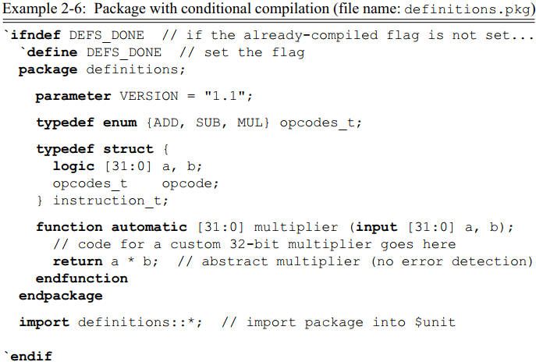
- Include the package at the beginning of every design/testbench file that needs the definitions in the package as shown below.
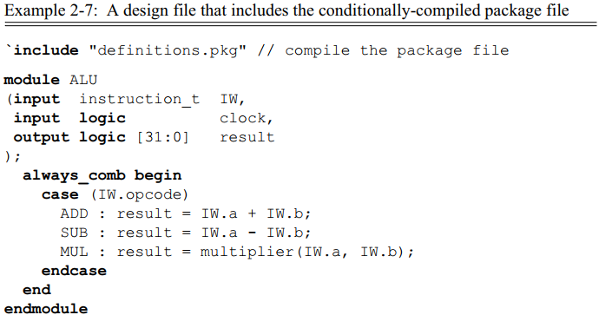
Notice that .pkg files do not need to be compiled separately as they are indirectly compiled when included in other design/testbench files.

Time Definitions

Time Values with Time Units
SystemVerilog extends the Verilog language by allowing time units to be specified as part of the time value.
Notice that no space is allowed between the time value and the time unit. The time units can be any of the following:
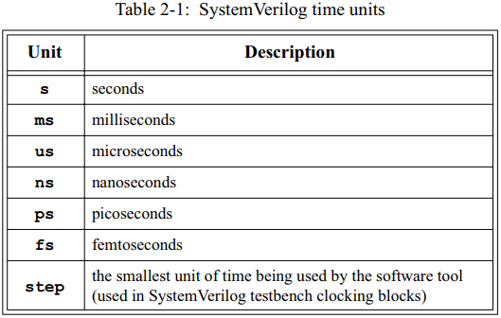

Scope-Level Time Unit and Precision
SystemVerilog allows the time units and time precision of time values to be specified locally, as part of a module, interface or program block, instead of as commands to the software tool using the keywords timeunit and timeprecision.
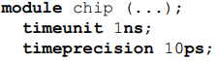

Time Unit and Precision Search Order
With SystemVerilog, the time unit and precision of a time value can be specified in multiple places. SystemVerilog defines a specific search order to determine a time value’s time unit and precision:
- If specified, use the time unit specified as part of the time value.
- Else, if specified, use the local time unit and precision specified in the module, interface or program block.
- Else, if the module or interface declaration is nested within another module or interface, use the time unit and precision in use by the parent module or interface.
- Else, if specified, use the `timescale time unit and precision in effect when the module was compiled.
- Else, if specified, use the time unit and precision defined in the compilation-unit scope.
- Else, use the simulator’s default time unit and precision.
The following example illustrates a mixture of delays. The comments indicate which declaration takes precedence.
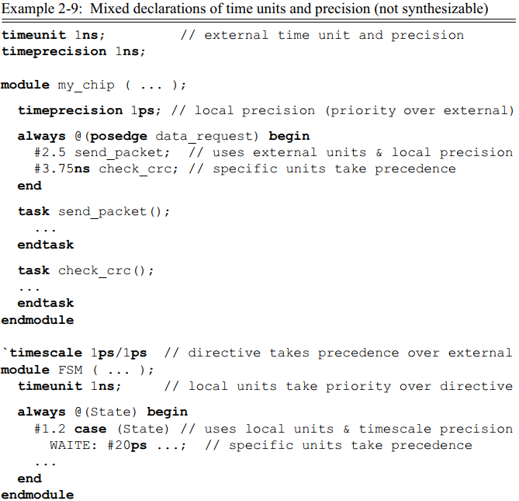

Chapter 3

Enhanced Literal Value Assignments
In the Verilog language, a vector can be easily filled with all zeros, all Xs (unknown), or all Zs (high-impedance).
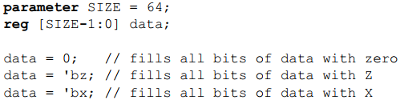
Each of the assignments in the example above is scalable. If the SIZE parameter is redefined, perhaps to 128, the assignments will automatically expand to fill the new size of data. However, Verilog does not provide a convenient mechanism to fill a vector with all ones. To specify a literal value with all bits set to one, a fixed size must be specified. For example:
data=64'hFFFFFFFFFFFFFFFF;
This last example is not scalable. If the SIZE constant is redefined to a larger size, such as 128, the literal value must be manually changed to reflect the new bit size of data. In order to make an assignment of all ones scalable, Verilog designers have had to learn coding tricks, such as using some type of operation to fill a vector with all ones, instead of specifying a literal value. The next two examples illustrate using a ones complement operator and a two’s complement operator to fill a vector with all ones:
data = ~0; // one's complement operation
data = -1; // two's complement operation
SystemVerilog enhances assignments of a literal value in two ways. First, a simpler syntax is added, that allows specifying the fill value without having to specify a radix of binary, octal or hexadecimal. Secondly, the fill value can also be a logic 1. The syntax is to specify the value with which to fill each bit, preceded by an apostrophe ( ' ), which is sometimes referred to as a “tick”. Thus:
- '0 fills all bits on the left-hand side with 0.
- '1 fills all bits on the left-hand side with 1.
- 'z or 'Z fills all bits on the left-hand side with z.
- 'x or 'X fills all bits on the left-hand side with x.

SystemVerilog Variables
In Verilog, we are used to always using reg or wire which are 4-state data types that can take the values 0, 1, x, or z. SystemVerilog adds several new 4-state and 2-state types of which the most important two are bit and logic (the other new data types are more suitable for modeling at more abstract levels than RTL, such as system level and transaction level). The only difference between them is that bit is a 2-state type, while logic is a 4-state type. From now on, you can dismiss using reg and wire and use either bit or logic. Which one to choose, bit or logic? Both are commonly used, but logic is usually preferred since 4-state types are the preferred types for synthesizable RTL hardware models (like reg and wire) since the z value is used to represent unconnected or tri-state design logic, and the x value is used to detect and isolate design errors. For example, 4-state variables default to beginning simulation with all bits at a logic X. These variables are considered uninitialized, and, therefore, at an unknown value until a first value is assigned to the variable (for example, by the design reset logic). On the other hand, 2-state data types begin simulation with a logic 0. Since 2-state types do not store an X value, they cannot represent an uninitialized state. This is one of the reasons that it is preferable to use 4-state types to represent synthesizable RTL. But from the synthesis point of view, both bit and logic are treated the same.
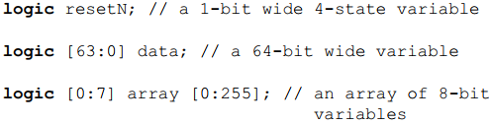
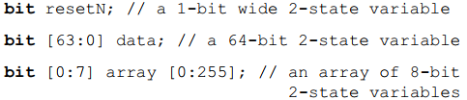

Chapters 4 and 8

User-Defined Types
SystemVerilog user-defined types are created using the typedef keyword, as in C. User-defined types allow new type definitions to be created from existing types. Once a new type has been defined, variables of the new type can be declared. For example:
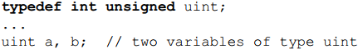
Usually, we define user-defined types in packages. Also, to make source code easier to read and maintain, a common naming convention is to end all user-defined types with the characters “_t”.

Enumerated Types
Enumerated types provide a means to declare an abstract variable that can have a specific list of valid values. Each value is identified with a user-defined name, or label. In the following example, variable RGB can have the values of red, green and blue:
In addition to specifying a set of unique labels, SystemVerilog provides two shorthand notations to specify a range of labels in an enumerated type list. The following example creates an enumerated list with the labels RESET, S0 through S4, and W6 through W9:
By default, the actual value represented by the label in an enumerated type list is an integer of the int type. The first label in the enumerated list is represented with a value of 0, the second label with a value of 1, the third with a value of 2, and so on. SystemVerilog allows the value for each label in the enumerated list to be explicitly declared. This allows the abstract enumerated type to be refined, if needed, to represent more detailed hardware characteristics. For example, a state machine sequence can be explicitly modeled to have one-hot values, one-cold values, Johnson-count, Gray-code, or other type of values. In the next example, the label A is explicitly given a value of 1, B is automatically given the incremented value of 2 and C the incremented value of 3. X is explicitly defined to have a value of 24, and Y and Z are given the incremented values of 25 and 26, respectively.
In order to represent hardware at a more detailed level, SystemVerilog allows an explicit base type for the enumerated types to be declared. For example:
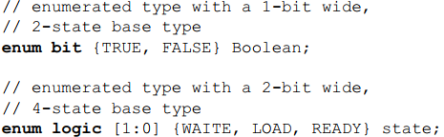
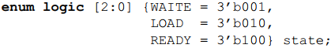
The following example shows the case that you will always need enum in, which is modeling an FSM:
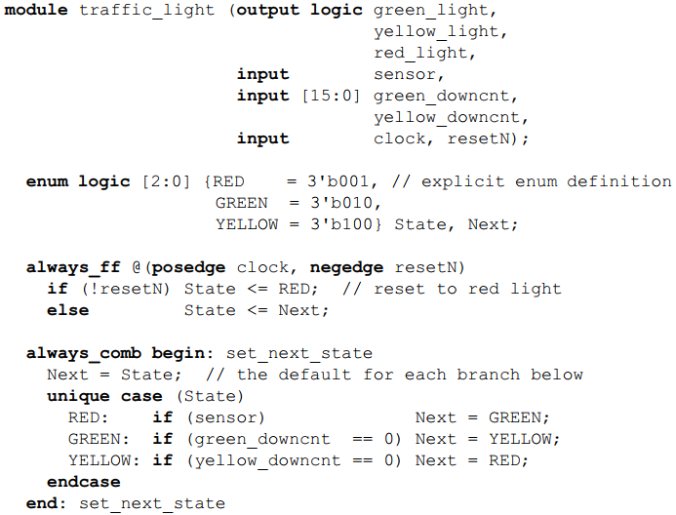
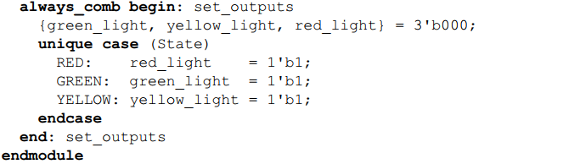

Chapter 5

Structures
Design data often has logical groups of signals, such as all the control signals for a bus protocol, or all the signals used within a state controller. The Verilog language does not have a convenient mechanism for collecting common signals into a group. Instead, designers must use ad-hoc grouping methods such as naming conventions where each signal in a group starts or ends with a common set of characters. SystemVerilog adds C-like structures to Verilog. A structure is a convenient way of grouping several pieces of related information together. A structure is declared using the struct keyword. Structure members can be any variable type, including user-defined types, and any constant type. An example structure declaration is:
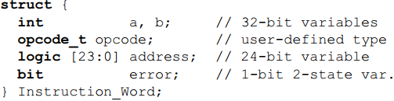
A structure is a collection of variables and/or constants under a single name. The entire collection can be referenced using the name of the structure. Each member within the structure also has a name, which is used to select it from the structure. A structure member is referenced the same as in C.
For example, to assign a value to the opcode member of the preceding structure, the reference is:
User-defined types can be created from structures, using the typedef keyword. Declaring a structure as a user-defined type does not allocate any storage. Before values can be stored in the members of a structure that is defined as a user-defined type, a variable of that user-defined type must be declared.
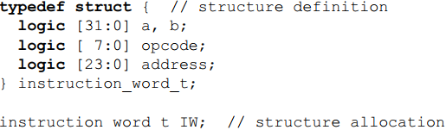
When a structure is declared without using typedef, it is referred to as an anonymous structure.
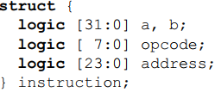
The members of a structure can be initialized at the time the structure is instantiated, using a set of values enclosed between the tokens ’{ and }. The number of values between the braces must exactly match the number of members in the structure.
The previous comma-separated list assignment can be used anywhere, not only during instantiation.
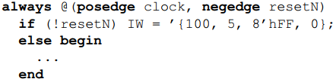
The values in the structure expression can be listed in the order in which they are defined in the structure. Alternatively, the structure expression can specify the names of the structure members to which values are being assigned, where the member name and the value are separated by a colon. When member names are specified, the expression list can be in any order.
Structures can be passed through module and interface ports. The structure must first be defined as a user-defined type using typedef, which then allows the module or interface port to be declared as the structure type.
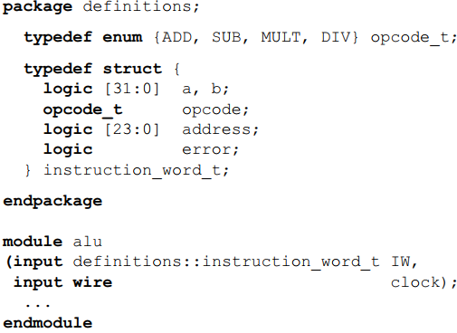

Unions
I felt unions are useless, so I skipped them.

Arrays

Unpacked Arrays
The syntax of an unpacked array declaration is:
<data type> <array name> <array dimensions>
For example:
logic table [3:0] [7:0];
Notice that an unpacked array dimensions come after the signal name.
With unpacked arrays, each element of the array may be stored independently from other elements but grouped under a common array name. Verilog does not define how software tools should store the elements in the array. For example, the following figure illustrates how the previous declaration might be stored within memory.
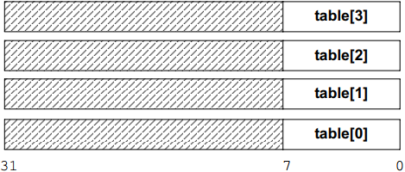

Packed Arrays
The syntax of a packed array declaration is:
<data type> <array dimensions> <array name>
For example:
logic [3:0] [7:0] data;
Notice that a packed array dimensions come before the signal name.
SystemVerilog defines how the elements of a packed array are stored. The entire array must be stored as contiguous bits, which is the same as a vector. Each dimension of a packed array is a sub field within the vector. In the packed array declaration above, there is an array of 4 8-bit sub-arrays. The following figure illustrates how the two-dimensional array above will be stored, regardless of the software compiler, operating system or platform.
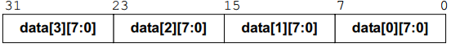

Mixed Packed and Unpacked Arrays
It is common to have a combination of unpacked arrays and packed arrays. The following example declares an unpacked array of 64-bit packed arrays:
When indexing arrays of arrays, unpacked dimensions are referenced first, from the left-most dimension to the right-most dimension. Packed dimensions (vector fields) are referenced second, from the left-most dimension to the right-most dimension. The following figure illustrates the order in which dimensions are selected in a mixed packed and unpacked multi-dimensional array.
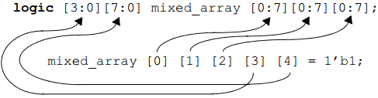
In Verilog, a packed array is referred to as a vector and is limited to a single dimension. Verilog allows packed arrays to be passed through module ports, or to be passed in or out of tasks and functions. Verilog does not allow unpacked arrays to be passed through module ports, tasks or functions. SystemVerilog extends Verilog by allowing arrays of any type and any number of dimensions to be passed through ports or task/function arguments.

Using Packed and Unpacked Arrays
There are some guidelines in the book on when to use each of them, but there are no mentioned reasons, so I am not convinced. So, in my opinion, always use the mixed packed and unpacked arrays syntax to declare multi-dimensional arrays.

The Foreach Array Looping Construct
SystemVerilog adds a foreach loop, which can be used to iterate over the elements of single- and multi-dimensional arrays, without having to specify the size of each array dimension. The argument to a foreach loop is the name of an array followed by a comma-separated list of loop variables enclosed in square brackets. Each loop variable corresponds to one of the dimensions of the array.
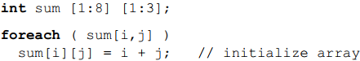
It is not necessary to specify a loop variable for each dimension of an array. A dimension can be skipped by showing a variable position using two commas, without a variable name. Empty loop variables indicate that the loop will not iterate over that dimension of the array. Contiguous empty loop variables at the end of the variable list can be omitted without listing the additional commas.
int sum [1:8] [1:3][2:8][3:9];
foreach (sum[i,,j])
sum[i][2][j][5] = i + j;

Chapter 6
The Verilog language provides a general-purpose procedural block, called always, that is used to model a variety of hardware types as well as verification routines. The multi-function role of the general purpose always procedural block places a substantial burden on software tools such as synthesis compilers and formal verification. It is not enough for these types of tools to execute the statements within the procedural block. Synthesis compilers and formal verification tools must also try to deduce what type of hardware is being represented—combinational, latched or sequential logic. To infer the proper type of hardware implementation, synthesis compilers and formal tools must examine the statements and event controls within the procedural block. SystemVerilog adds three specialized procedural blocks to reduce the ambiguity of the Verilog general purpose always procedural block when modeling hardware. These are: always_comb, always_latch, and always_ff. The specialized always_comb, always_latch, and always_ff procedural blocks indicate the design intent. Software tools do not need to infer from context what the designer intended, as must be done with the general purpose always procedural block. If the content of a specialized procedural block does not match the rules for that type of logic, software tools can issue warning messages. By using always_comb, always_latch, and always_ff procedural blocks, the engineer’s intent is clearly documented for both software tools and for other engineers who review or maintain the model.

Combinational Logic Procedural Blocks
Unlike the general purpose always procedural block, it is not necessary to specify a sensitivity list with always_comb. A combinational logic sensitivity list can be automatically inferred, because software tools know that the intent is to represent combinational logic.
An important advantage of always_comb over the general purpose always procedural block is that when always_comb is specified, the designer’s intent is clearly stated. In the following example with a general-purpose always procedural block, a software tool cannot know what type of logic the designer intended to represent, and consequently will infer that latched logic was intended, instead of combinational logic.
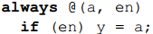
With SystemVerilog, this same example could be written as follows:
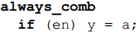
Software tools can then tell from the always_comb keyword that the designer’s intent was to model combinational logic and can issue a warning that a latch would be required to realize the procedural block’s functionality in hardware.

Latched Logic Procedural Blocks
The always_latch procedural block is used to indicate that the intent of the procedural block is to model latch-based logic. always_latch infers its sensitivity list, just like always_comb.
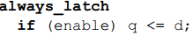

Sequential Logic Procedural Blocks
The always_ff specialized procedural block indicates that the designer’s intent is to model synthesizable sequential logic behavior.
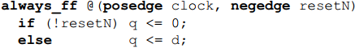

Enhancements to Tasks and Functions
I skipped this part since I don’t usually use tasks and functions, but you can read it as SystemVerilog adds a few enhancements to tasks and functions compared to Verilog.

Chapter 7

New Operators
SystemVerilog adds the ++ increment operator and the -- decrement operator to the Verilog language. These operators are used in the same way as in C. For example:
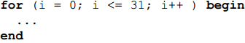
As in C, the increment and decrement operators can be used to either pre-increment/pre-decrement a variable, or to post-increment/post-decrement a variable. The table below shows the four ways in which the increment and decrement operators can be used.
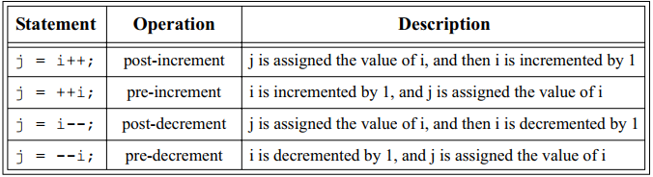
The increment and decrement operators behave as blocking assignments. The following two statements are semantically equivalent:
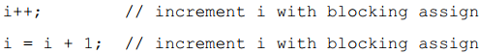
Just as it is possible to misuse the Verilog blocking assignment, creating a race condition within simulation, it is also possible to misuse the increment and decrement operators. The following example illustrates how an increment or decrement operator could be used in a manner that would create a simulation race condition. In this example, a simple counter is incremented using the ++ operator. The counter, which would be implemented as sequential logic using some form of flip-flops, is modeled using a sequential logic always_ff procedural block. Another sequential logic procedural block reads the current value of the counter and performs some type of functionality based on the value of the counter.
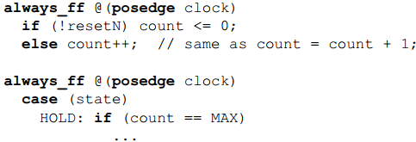
Since count++ is equivalent to count = count + 1, and we know we should be using count <= count + 1, a race condition might occur in the previous example. A non-blocking assignment is required to prevent potential race conditions.
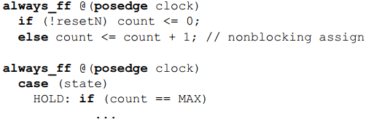
The guideline for using ++ and -- is to only use them to model combinational logic. Sequential and latched logic procedural blocks should not use the increment and decrement operators to modify any variables that are to be read outside of the procedural block. Temporary variables that are only read within a sequential or latched logic procedural block can use the ++ and -- operators without race conditions. For example, a variable used to control a for loop can use the ++ or -- operators even within a sequential procedural block, so long as the variable is not read anywhere outside of the procedural block.
SystemVerilog adds several additional operators shown in the table below.
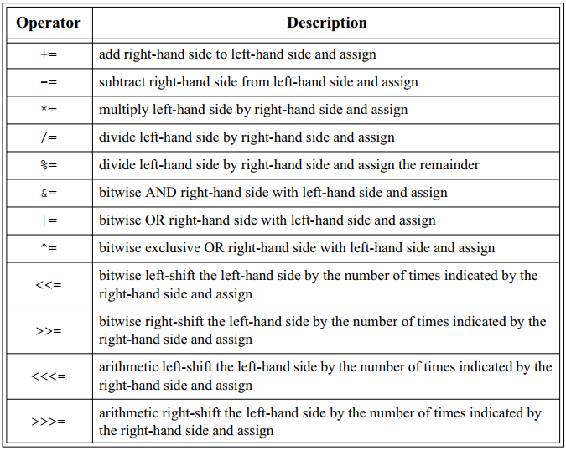
The same guidelines apply with these operators; to avoid any race conditions, these operators must be used to model combinational logic only.
SystemVerilog adds an operator to test if a value matches anywhere within a set of values. The operator uses the keyword, inside.
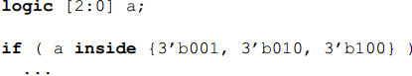
The inside operator can simplify comparing a value to several possibilities. Without the inside operator, the preceding if decision would likely have been coded as:

Operand Enhancements

Sign Casting
SystemVerilog also allows explicitly casting the signedness of a value. The syntax for the sign casting operation is:
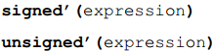
Some examples of sign casting are:
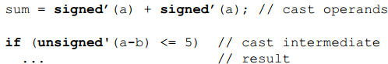
The SystemVerilog sign cast operator performs the same conversion as the Verilog $signed and $unsigned system functions. Sign casting is synthesizable, following the same rules as the $signed and $unsigned system functions.

Enhanced for Loops
With SystemVerilog, the declaration of the for loop variable can be made within the for loop itself. This eliminates the need to define several variables at the module level.
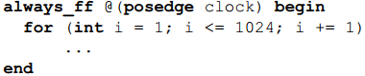

Enhanced Block Names
Complex code will often have several nested begin...end statement blocks. In such code, it can be difficult to recognize which end is associated with which begin. The following example illustrates how a single procedural block might contain several nested begin...end blocks. Even with proper indenting and keyword bolding as used in this short example, it can be difficult to see which end belongs with which begin.
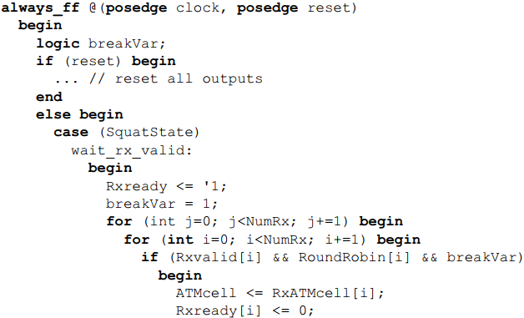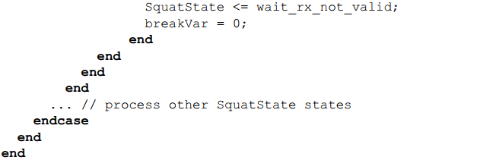Verilog allows a statement block to have a name, by appending :<name> after the begin keyword. SystemVerilog allows (but does not require) a matching block name after the end keyword. This additional name does not affect the block semantics in any way but does serve to enhance code readability by documenting which statement group is being completed.
The following code snippet modifies the previous example by adding names to the begin...end statement groups, helping to make the code easier to read.
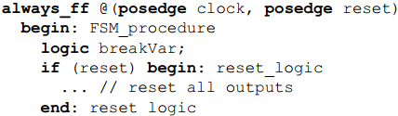
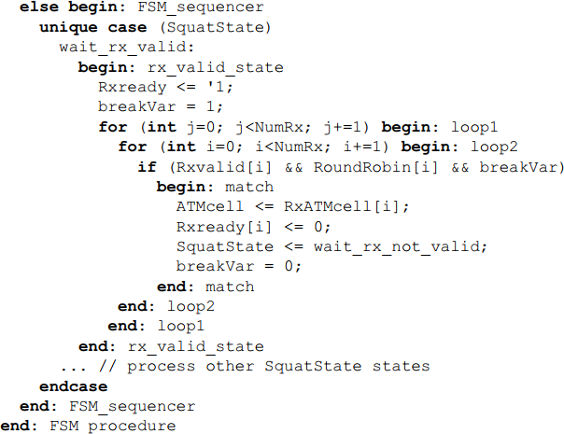

Statement Labels
In addition to named blocks of statements, SystemVerilog allows a label to be specified before any procedural statement. Statement labels use the same syntax as C:
A statement label is used to identify a single statement, whereas a named statement block identifies a block of one of more statements.
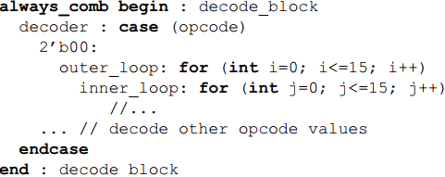
A begin...end block is a statement and can therefore have either a statement label or a block name.
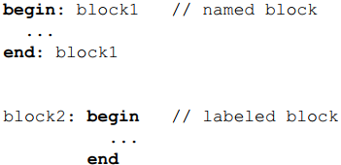
It is illegal to give a statement block both a label and a block name.

Unique Case Statements


The use of the unique modifier to the case statement in the preceding example is important. The unique modifier to the case statement specifies three things. First, unique case specifies that all case selection items can be evaluated in parallel, without priority encoding. Software tools such as synthesis compilers can optimize the decoding logic of the case selection items to create smaller, more efficient implementations. This aspect of unique case is the same as synthesis parallel_case pragma. Second, unique case specifies that there should be no overlap in the case selection items. During the run-time execution of tools such as simulation, if the value of the case expression satisfies two or more case selection items, a run-time warning will occur. This semantic check can help trap design errors early in the design process. The synthesis parallel_case pragma does not provide this important semantic check. Third, unique case specifies that all values of the case expression that occur during simulation must be covered by the case selection items. With unique case, if a case expression value occurs that does not cause a branch of the case statement to be executed, a runtime warning will occur. This semantic check can also help trap design errors much earlier in the design cycle. This is similar to the full_case pragma for synthesis, but the synthesis pragma does not require that other tools perform any checking.

Priority Case Statements
A priority case statement specifies that:
- At least one case select expression must match the case expression when it is evaluated.
- If more than one case select expression matches the case expression when it is evaluated, the first matching branch must be taken.
The priority modifier indicates that the designer considers it to be OK for two or more case selection expressions to be true at the same time, and that the order of the case selection items is important. In the following example, the designer has specified that there is priority to the order in which interrupt requests are decoded, with irq0 having the highest priority.
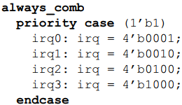
Because the model explicitly states that case selection items should be evaluated in order, all software tools must maintain the inferred priority encoding, should it be possible for multiple case selection items to match.

Enhanced if...else Decisions
The SystemVerilog unique and priority decision modifiers also work with if...else decisions. These modifiers can also reduce ambiguities with this type of decision and can trap potential design errors early in the modeling phase of a design.
The Verilog if...else statement is often nested to create a series of decisions. For example:
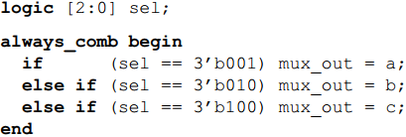
In simulation, a series of if...else...if decisions will be evaluated in the order in which the decisions are listed. To maintain the same ordering in hardware implementation, priority encoded logic would be required. Often, however, the specific order is not essential in the desired logic. The order of the decisions is merely the way the engineer happened to list them in the source code.

Unique if...else Decisions
The unique modifier indicates that the designer’s intent is that the order of the decisions is not important. Software tools can optimize the inferred priority of the decision order. For example:
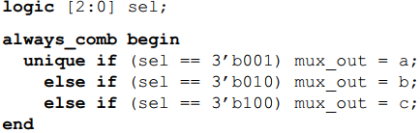
A unique if...else cannot have overlapping conditions. Software tools will perform checking on a unique if decision sequence to ensure that all decision conditions in a series of if...else...if decisions are mutually exclusive. This allows the decision series to be executed in parallel, without priority encoding. A software tool will generate a run-time warning if it determines that more than one condition is true. This warning message can occur at either compile time or run-time. This additional checking can help detect modeling errors early in the verification of the model.
In the following example, there is an overlap in the decision conditions. Any or all the conditions for the first, second and third decisions could be true at the same time. This means that the decisions must be evaluated in the order listed, rather than in parallel. Because the unique modifier was specified, software tools can generate a warning that the decision conditions are not mutually exclusive.
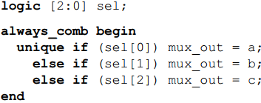
A unique if...else warns of unspecified conditions. When the unique modifier is specified with an if decision, software tools are required to generate a run-time warning if the if statement is evaluated and no branch is executed. The following example would generate a run-time warning if the unique if...else...if sequence is entered and sel has any value other than 1, 2 or 4.
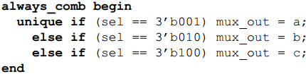
This run-time semantic check guarantees that all conditions in the decision sequence that occur during run time have been fully specified. When the decision sequence is evaluated, one branch will be executed. This helps ensure that the logic represented by the decisions can be implemented as combinational logic, without the need for latches.

Priority if...else Decisions
The priority modifier indicates that the designer’s intent is that the order of the decisions is important. Software tools should maintain the order of the decision sequence. For example:
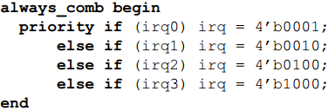
Because the model explicitly states that the decision sequence above should be evaluated in order, all software tools should maintain the inferred priority encoding. The priority modifier ensures consistent behavior from software tools. Simulators, synthesis compilers, equivalence checkers, and formal verification tools can all interpret the decision sequence in the same way.
As with the unique modifier, when the priority modifier is specified with an if decision, software tools will perform run-time checks that a branch is executed each time an if...else...if sequence is evaluated. A run-time warning will be generated if no branch of a priority if...else...if decision sequence is executed. This helps ensure that all conditions in the decision sequence that actually occur during run time have been fully specified, and that when the decision sequences are evaluated, a branch will be executed. The logic represented by the decision sequence can be implemented as priority-encoded combinational logic, without latches.

Chapter 9

Simplified Netlists of Module Instances
A netlist is a list of module instances, with nets connecting the ports of the instances together. Netlists are often generated from software tools, such as synthesis compilers; but netlists are also often defined by hand, such as when connecting design blocks together. Even at the block level, with top-level models, netlists can often be quite large, with a high potential for connection errors that can be difficult to debug. Consider the following example using Verilog’s named port connections.
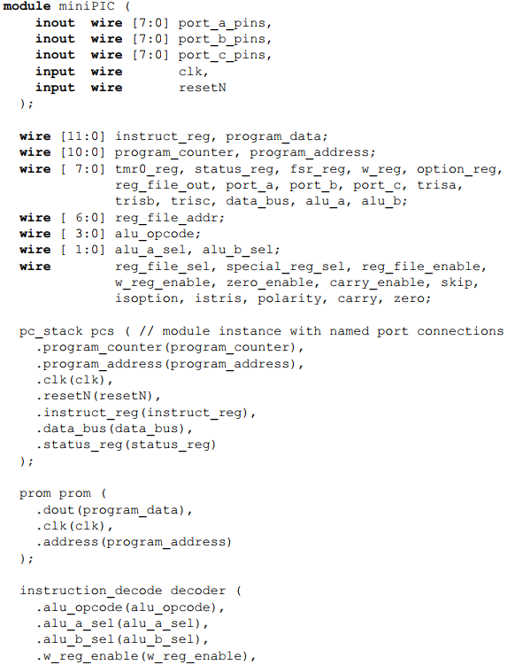
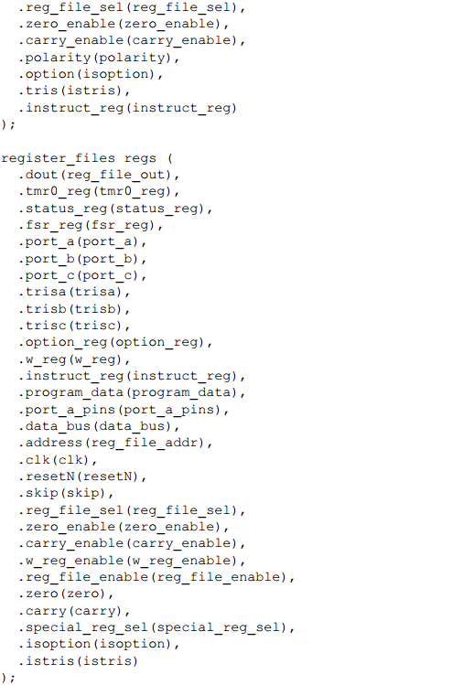
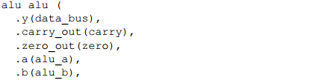
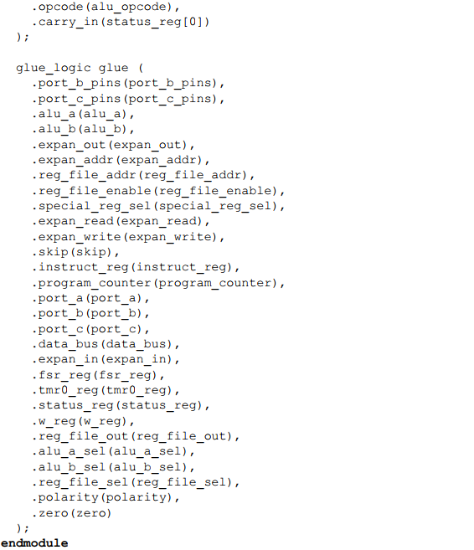
The disadvantage of the named port connection style is that it is very verbose. Netlists can contain tens or hundreds of module instances, and each instance can have dozens of ports. Both the name of the port and the name of the net connected to the port must be listed for each and every port connection in the netlist. Port and net names can be up to 1024 characters long in Verilog tools. When long, descriptive port names and net names are used, and there are many ports for each module name, the size and verbosity of a netlist using named port connections can become excessively large and difficult to maintain.

Implicit .name Port Connection
SystemVerilog provides three enhancements that greatly simplify netlists: .name (pronounced “dot-name”) port connections, .* (pronounced “dot-star”) port connections, and interfaces. The .name and .* styles are discussed in the following subsections, and interfaces are presented in Chapter 10.
In many Verilog netlists, especially top-level netlists that connect major design blocks together, it is common to use the same name for both the port name and the name of the net connected to the port. For example, the module might have a port called data, and the interconnected net is also called data. Using Verilog’s named port connection style, it is necessary to repeat the name twice in order to connect the net to the port, for example: .data(data). SystemVerilog simplifies the named port connection syntax by allowing just the port name to be specified. When only the port name is given, SystemVerilog infers that a net or variable of the same name will automatically be connected to the port. This means the verbose Verilog style of .data(data) can be reduced to simply .data.
The following example simplies the example shown previously using SystemVerilog’s .name port conection styles for all nets that are the same name as the port.
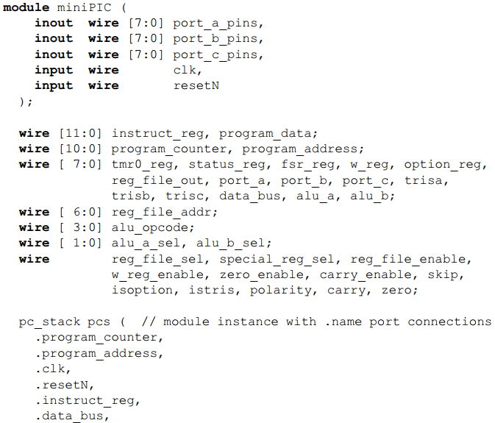
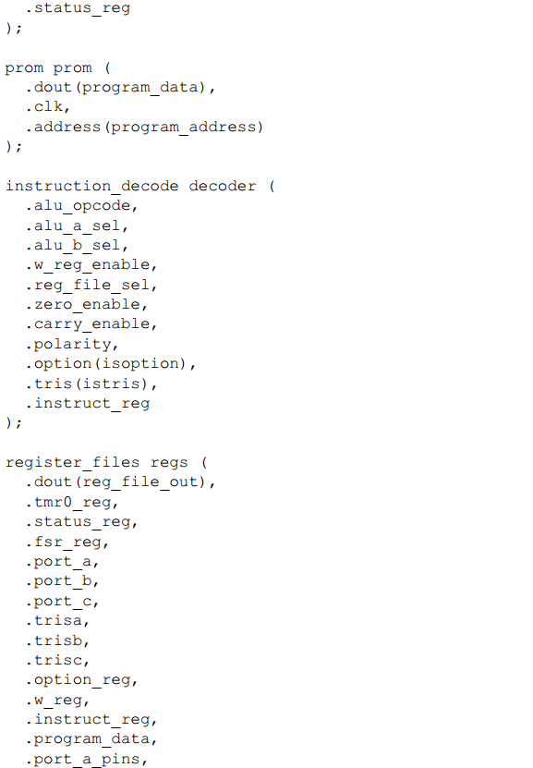
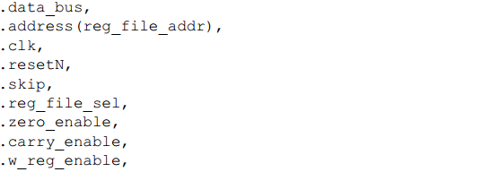
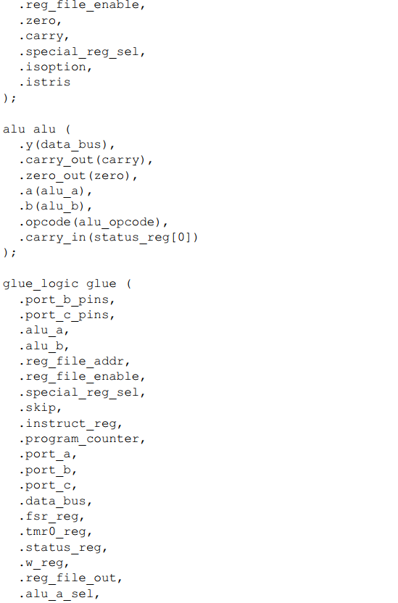
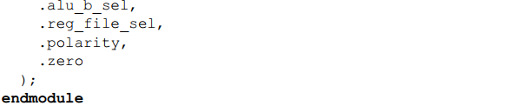

Implicit .* Port Connection
SystemVerilog provides an additional short cut to simplify the specification of large netlists. The .* syntax indicates that all ports and nets (or variables) of the same name should automatically be connected for that module instance. As with the .name syntax, for a connection to be inferred, the name and vector size must match exactly, and the types connected must be compatible. Any connections that cannot be inferred by .* must be explicitly connected using Verilog’s named port connection syntax. The following example illustrates this:
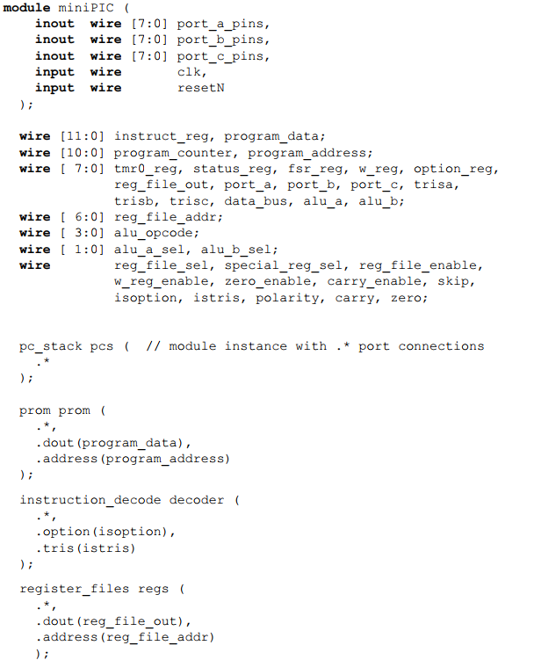
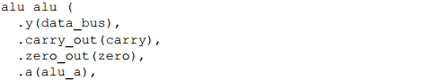
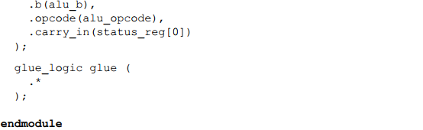

Net Aliasing
SystemVerilog adds an alias statement that allows two different names to reference the same net. For example:
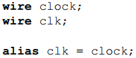
The net clk is an alias for clock, and clock is an alias for clk. Both names refer to the same logical net. Several nets can be aliased together. A change on any of the net names will be reflected on all of the nets that are aliased together.
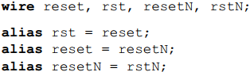
The previous set of aliases can also be abbreviated to a single statement containing a series of aliases, as follows:
The order in which nets are listed in an alias statement does not matter.
SystemVerilog imposes several restrictions on what signals can be aliased to another name. The most important rule is that only the net types can be aliased. Variables cannot be aliased. This means only wire can be used in aliasing, logic cannot be used.
The alias statement enables greater usage of the .name and .* shortcuts for modeling netlists. In the following example, however, these shortcuts cannot be fully utilized to connect the clock signals together, because the port names are not the same in each of the modules.
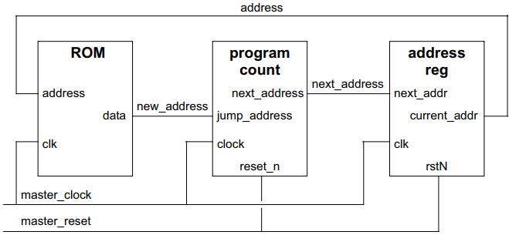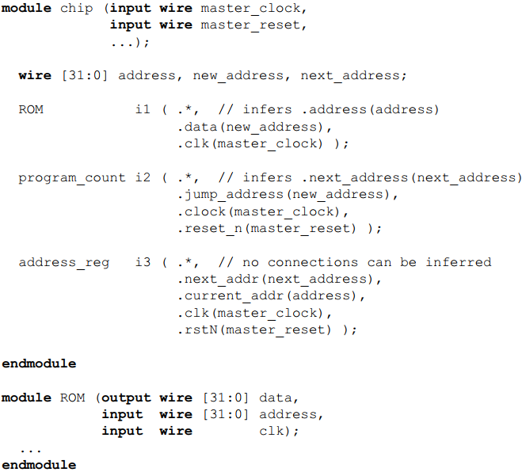
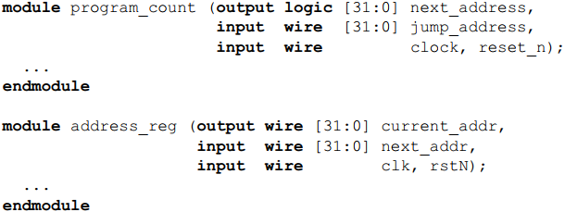
The following example adds alias statements, which allow the netlist to take full advantage of the .* shortcut to connect all modules together.
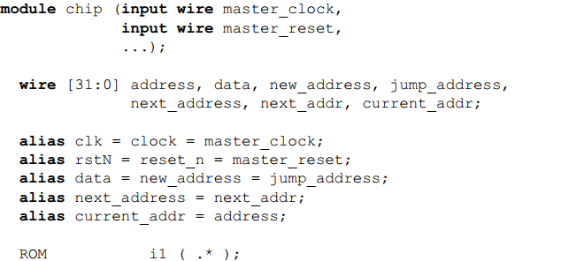
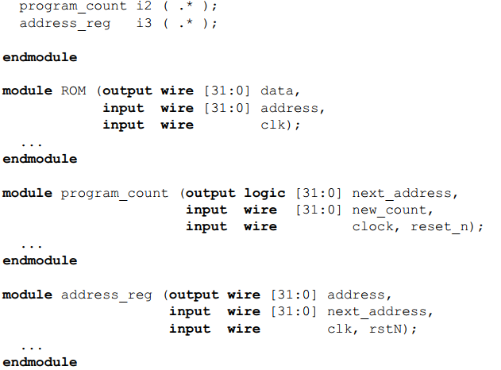

SystemVerilog Port Declarations
SystemVerilog simplifies the declaration of module ports in several ways:
- SystemVerilog specifies a default port direction of inout (bidirectional). Therefore, it is no longer required to specify a port direction, unless the direction is different than the default.
- if the next port in the port list has a type defined, but no direction is specified, the direction defaults to the direction of the previous port in the list.
An example is shown below:
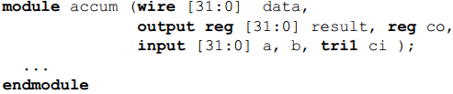
The first port in the list, data, has a type, but no explicit port direction. Therefore, this port defaults to the direction of inout. Port co also has a type, but no port direction. This port defaults to the direction of the previous port in the list, which is output. Ports a and b have a port direction declared, but no type. As with Verilog-2001 and Verilog-1995, an implicit net type will be inferred, which by default is the type wire. Finally, port ci has a type declared, but no port direction. This port will inherit the direction of the previous port in the list, which is input.

Chapter 10
Consider the following example that connects five blocks of a design together using a rudimentary bus architecture called main_bus, plus some additional connections between some of the design blocks. Figure 10-1 shows the block diagram for this simple design, and example 10-1 lists the Verilog source code for the module declarations involved.
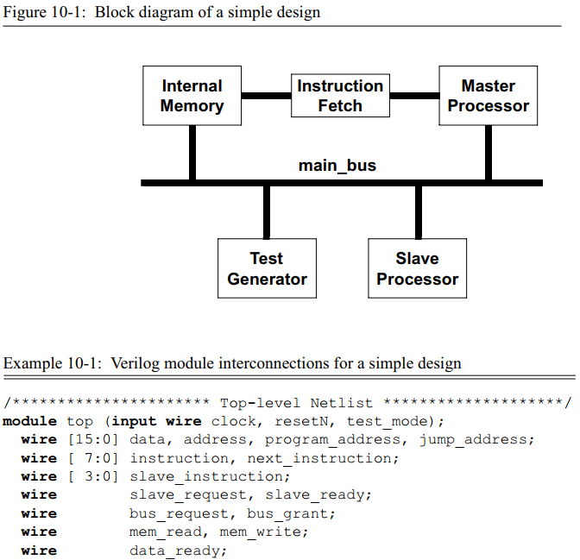
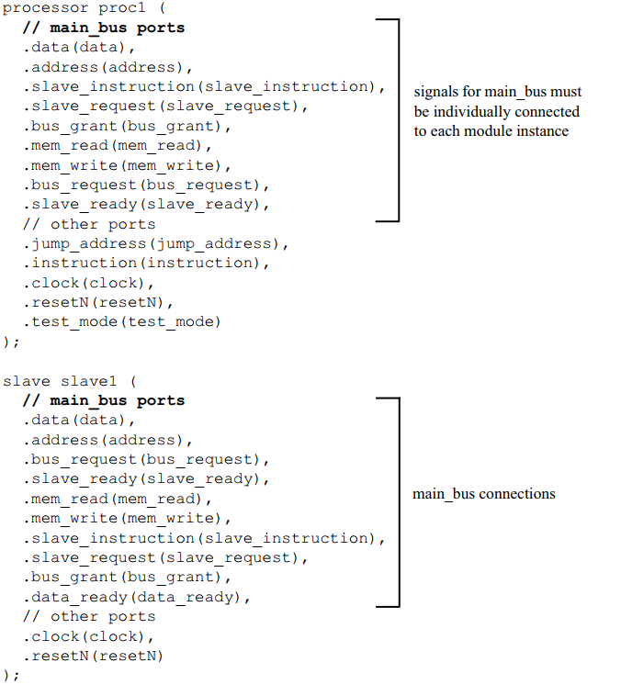
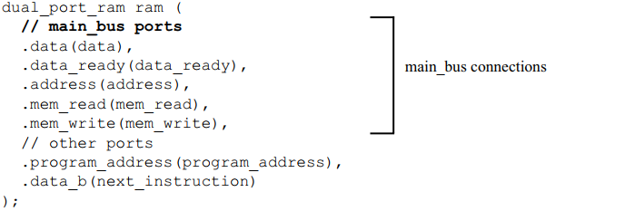
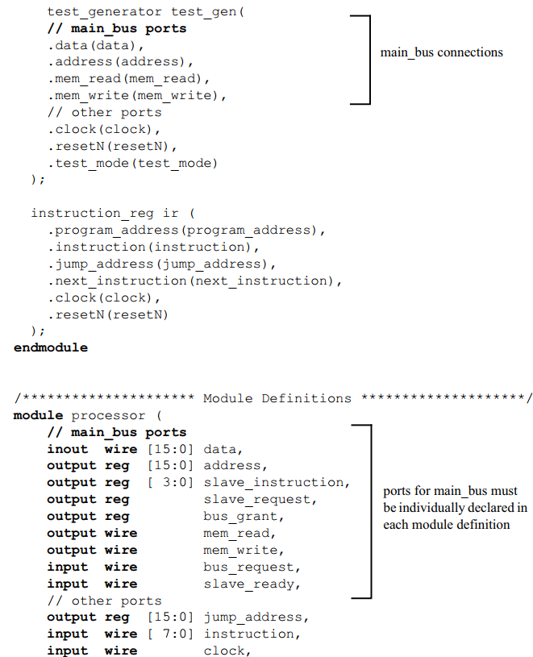
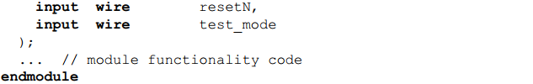
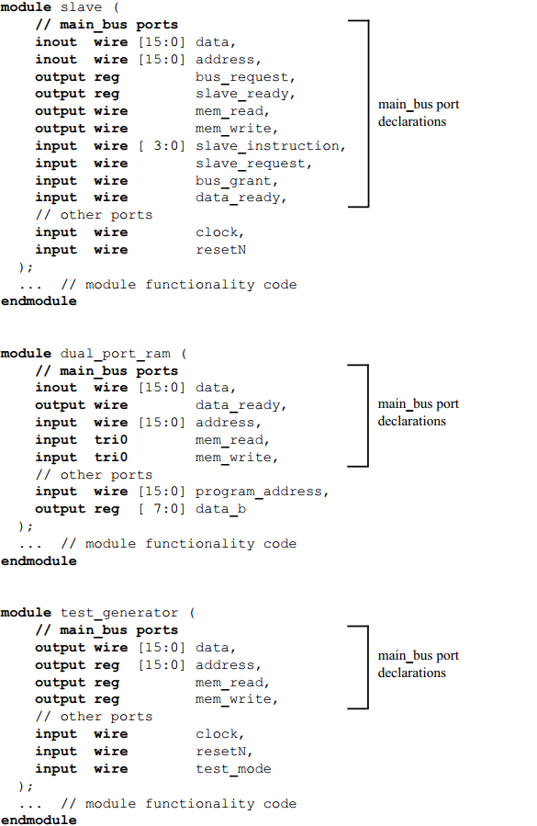
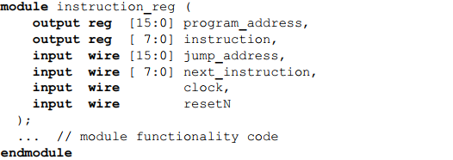
One disadvantage of using Verilog’s module ports to connect major blocks of a design together is readily apparent in the example code above. The signals that make up main_bus in the preceding example must be declared in each module that uses the bus, as well as in the top-level netlist that connects the design together. In this simple example, there are only a handful of signals in main_bus, so the redundant declarations are mostly just an inconvenience. In a large, complex design, however, this redundancy becomes much more than an inconvenience. A large design could have dozens of modules connected to the same bus, with dozens of duplicated declarations in each module.
SystemVerilog adds a powerful new port type to Verilog, called an interface. An interface allows a number of signals to be grouped together and represented as a single port. The declarations of the signals that make up the interface are contained in a single location. Each module that uses these signals then has a single port of the interface type, instead of many ports with the discrete signals.
Example 10-2 shows how SystemVerilog’s interfaces can reduce the amount of code required to model the simple design shown in Figure 10-1. By encapsulating the signals that make up main_bus as an interface, the redundant declarations for these signals within each module are eliminated.
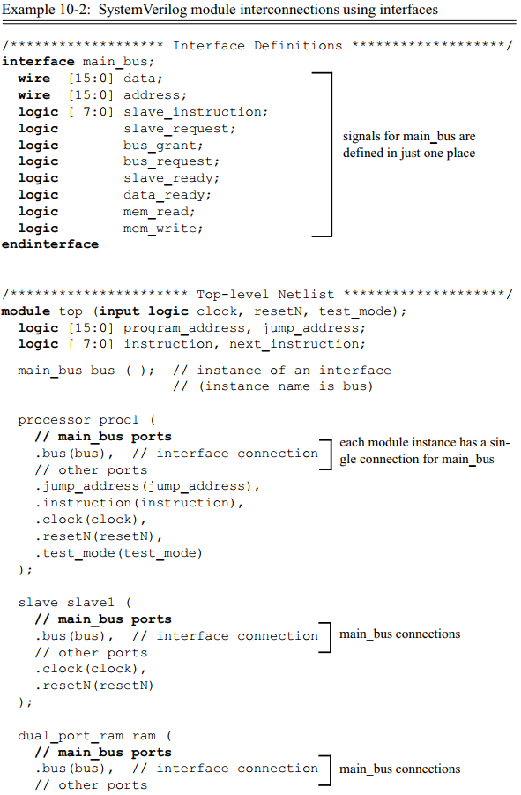
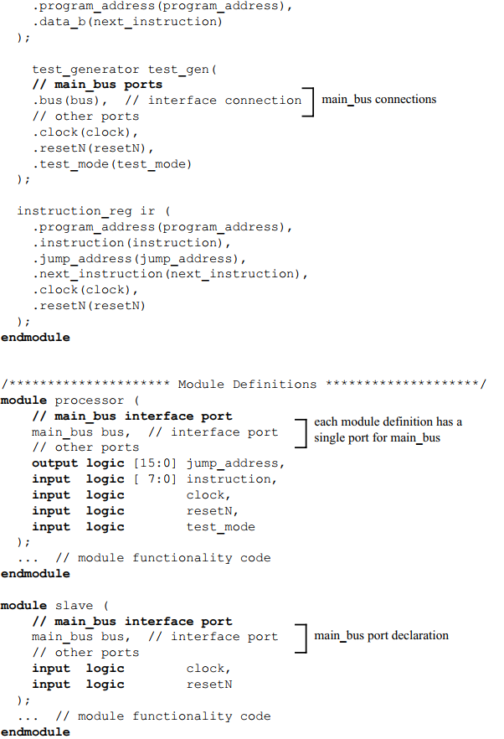
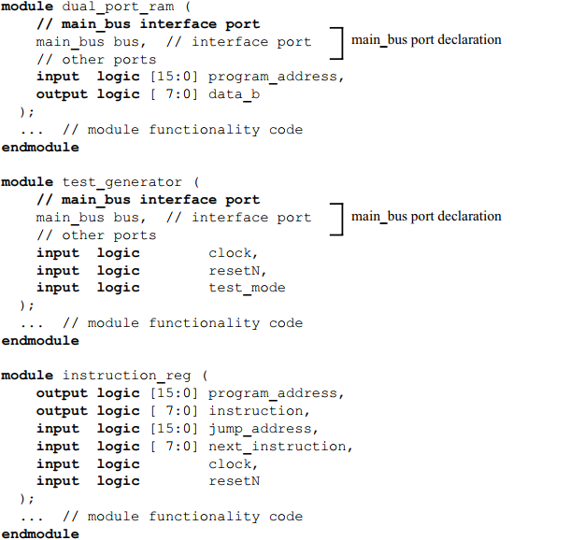
Syntactically, the definition of an interface is very similar to the definition of a module. An interface can have ports, just as a module does. This allows signals that are external to the interface, such as a clock or reset line, to be brought into the interface and become part of the bundle of signals represented by the interface. Example 10-3 shows a definition for an interface called main_bus, with three external signals coming into the interface: clock, resetN and test_mode. These external signals can now be connected to each module through the interface, without having to explicitly connect the signals to each module.
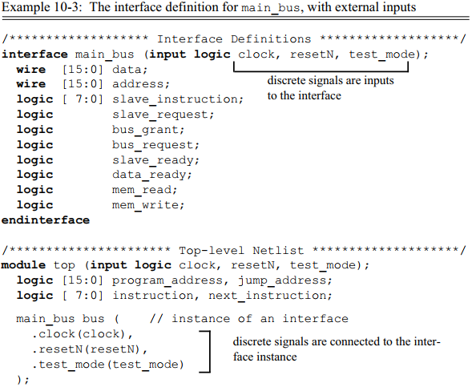
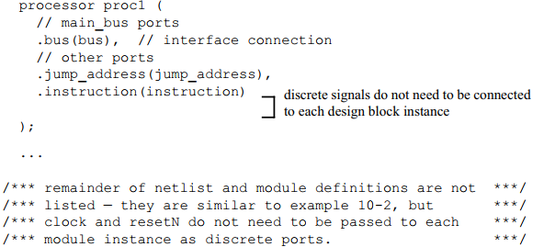
The SystemVerilog simplified port connection styles of .name and .* can also be used with interface port connections.

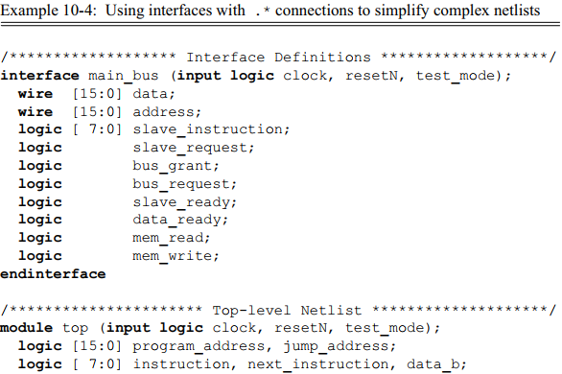
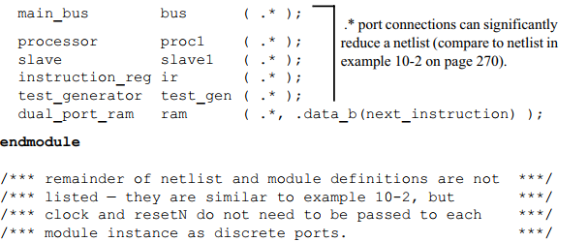
A port can be declared using the interface keyword to define the port as a generic interface. When the module is instantiated, any interface can be connected to the generic interface port.
